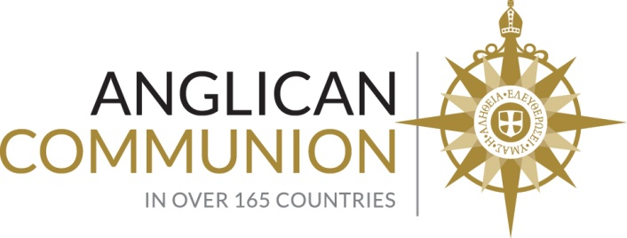

Interactive Civil Society Hearing on the Fight to End Tuberculosis

On June 4th, 2018 the UN held an Interactive Civil Society Hearing on the Fight to End Tuberculosis (TB)^{i} at the United Nations Headquarters in New York City. This civil society hearing gave a platform for panelists to bring up prominent issues in the struggle against the epidemic, and also laid the foundation for the first high-level meeting on TB which will be held on September 26, 2018, at which the Anglican Communion Office at the UN will also be present. TB has recently replaced HIV as the number one infectious killer in the world. Although international organizations and groups have brought this issue to public attention, recent collective efforts to fight TB have still been insufficient to meet the relevant Sustainable Development Goals (SDG)^{ii} target, specifically Goal 3:^{iii} to “ensure healthy lives and promote well-being for all at all ages”. The President of the General Assembly, Miroslav Lajčák, emphasized the need for immediate action from member states to designate funding for TB research and target populations that are at the highest risk. In an opening statement,^{iv} UN Secretary General Antonio Guterres noted that though the fight may not be easy, cooperation across different sectors will keep the world on track to end Tuberculosis by 2030. This meeting attempted to raise more awareness of the issue as well as to gather more funding and support from each of the member states.

The panel first addressed the problem of the missing cases. Many Tuberculosis patients are unidentified or neglected by national health systems due to reasons such as lack of nearby medical facilities or attempts at self-medication. Angelina Tan, a congresswoman from the Philippines, stressed the importance of appropriate diagnosis since only 19% of Tuberculosis patients in her country seek proper medical attention. The panel collectively recommended that governments invest more resources into expanding coverage of medical check-ups and screenings. Early diagnosis of TB can prevent irreversible damages to the body and hastens medical treatment, thus lowering medical costs. Once the issue of diagnosis is addressed, the panel urged governments to provide affordable treatment of TB to their citizens to guarantee their inalienable rights to medical care.

The second issue the panel addressed is the shortage of healthcare workers who work on the frontlines. The risk of being infected with a potentially fatal disease deters people from such dangerous work. Delegates stated that it is imperative for governments to ensure workers’ safety in order to further encourage their meaningful role. Delegates further underscored the importance of prioritizing adequate and sustainable funding for the provision of safety equipment for frontline workers.

The hearing also identified a group of people most at risk of infection: children. Children have a much higher chance of infection due to their weaker immune systems, especially those in marginalized communities. Currently, fewer than 13% of children have preventive therapy for TB. Parents who are infected with TB and do not have access to proper treatment and diagnosis themselves can easily infect their children, and the current treatment methods are much more harmful for young children and could inflict numerous lifetime side effects.

TB survivor Ingrid Schoeman^{v} spoke about her experience while being treated for a form of drug resistant tuberculosis. Due to her condition and the treatment itself, Ingrid was hospitalized for 75 days, developed liver failure, and survived through a coma. Experiences of these imperfect treatment methods brought the delegates to emphasize the importance of TB preventive methods as an alternative method. The Elizabeth Glaser Pediatric AIDS Foundation (EGPAF) strongly advocated for wider use of the Isoniazid Preventive Therapy (IPT), a low cost preventive treatment for high risk patients, and the Bacillus Calmette–Guérin (BCG) vaccination, which is an immunization for infants who are at a high risk for contracting TB. This organization hoped to expand the vaccine coverage to reduce the number of infected children.

Other high risk groups are located in densely populated areas, such as prisons and mines. These two population groups share similar characteristics of close proximity among humans and, often, a lack of proper medical care. Delegates recognized that screenings and checkups at these locations are especially important, particularly as prisoners will eventually be released into the general population and could contribute to the mass spread of tuberculosis. Early diagnosis is especially essential in these areas, as the close quarters could expose hundreds of individuals to the infectious killer. Moreover, Donald Tobaiwa, Director of Jointed Hands Welfare Organization, brought some light to the stigma that follows TB, and stated that many people avoid diagnosis and treatment due to the fear of being branded. He also noted that in some circumstances, attitudes of prison wardens and inhumane treatment of prisoners are contributing factors to the lack of screening and treatment and only add to the spread of disease.

The panel reinforced the idea that TB should not be a death sentence in this day and age. It is a curable and preventable disease, and modern advancement in the medical field needs to be supported in order to develop non-crippling treatment methods. The challenge that the World Health Organization (WHO) and other organizations face has a lot to do with the asymmetric commitment to fight this disease among different countries. The success of the eradication of TB will depend on the collective efforts of all member states to invest in preventative methods and encourage further research. Civil society plays a significant role in this battle and all key stakeholders are responsible for seizing momentum and materializing the movement. Faith-based organizations (FBOs) have tremendous influence around the world, often providing frontlines health services, and will be pivotal in these international efforts to end tuberculosis.

To learn more about the much anticipated High-Level Meeting on the Fight to End Tuberculosis click here.^{vi}

Inspired to take action? The Anglican Communion Office at the United Nations is partnering with the World Council of Churches to encourage religious leaders and faith communities to speak out for action against tuberculosis (TB). We are encouraging Anglicans to ask their governments to urgently take action to End TB. You can find out how to get involved in the campaign here.

By Brian Wong (Intern), Ashley Lopez Olijnyk, and Rachel Jimenez
Anglican Communion Office at the United Nations

i – https://www.un.org/pga/72/2018/06/04/civil-society-hearing-on-the-fight-against-tuberculosis/
ii – https://www.un.org/sustainabledevelopment/sustainable-development-goals/
iii – https://www.un.org/sustainabledevelopment/health/
iv – https://www.un.org/sg/en/content/sg/statement/2018-06-04/secretary-generals-remarks-interactive-civil-society-hearing
v – http://blogs.msf.org/en/patients/authors/ingrid-schoeman
vi – https://www.un.org/pga/72/event-latest/fight-to-end-tuberculosis/

